TMT/Delhi/S0702/2026. 11-03-.2026

To,

Mr. Sanjay Kumar Gupta

TRISHAKTI ENTERPRISES

Phone No : +919810046411

Mobile No : +919810046411, +919910046411, +919990397595

Email : trishaktienterprises63@gmail.com

City : Delhi

Dear Sir,

Sub :- Your Requirement of Slitting Line – 1660 mm Wide Thickness 3.0 mm {30 Ton}

We are very much thankful to you for your enquiry. As discussed, we are submitting hereunder the detailed offer for all items that are connected to the respective slitting machinery.

S No | Description of the unit | Offer
1. | Slitting machine along with un-coiler, Leveler Unit, Entry guide, shearing unit, slitter head, scrap winders – 2 No’s, drag wiper unit, coiler, separator and over arm units, delivery coil cars, along with power pack and other electrical connections Without cutters and Spacers | 1,80,00,000/- (Rupees one crore Eighty Lakhs Only)

LIST OF EQUIPMENTS
- Un-coiler – Hydraulic
- Pinch roll
- Vertical entry guide
- Tensioner pad
- Slitter Assembly
- Scrap winder -2 Nos.
- Loop pit with loop control
- Shear
- Pinch roll
- Re-coiler with over arm separator
- Turnstile
- Hydraulics
- Electrical
TECHNICAL SPEACIFICATION OF SILITING LINE

- TYPE : VARIABLE SPEED TYPE
- MATERIAL : G I Sheet / MS Sheet.
- COIL WEIGHT : Max. 30 Tons
- COIL WIDTH : MAX - 1660mm
- COIL WIDTH : MIN - 300.mm
- OUTSIDE DIA : MAX - 1650mm ,
- COIL BORE : 608,
- STRIP THICKNESS : 0.8 mm to 3.0 mm
- SLITTED COIL : inside dia 608 mm
- THREADING SPEED : 3 to 7 m/min.
- LINE SPEED : 40 m/min MAX
- NO. OF CUTS : 10 cuts Max
- DRIVE : AC motor
- ELECTRIC SUPPLY : Motors 415 volts ±5%, 3 phase 50 cycles AC
LIST OF EQUIPMENTS
- Un-coiler – Hydraulic
- Pinch roll
- Vertical entry guide
- Tensioner pad
- Slitter Assembly
- Scrap winder -2 Nos.
- Loop pit with loop control
- Shear
- Pinch roll
- Re-coiler with over arm separator
- Turnstile
- Hydraulics
- Electrical
TECHNICAL SPEACIFICATION OF SILITING LINE

TECHNICAL SPECIFICATIONS:

Maximum sheet width that can be slitted : 1660 MM

Maximum sheet thickness in MS that can be slitted : 3.0 MM

Minimum sheet thickness in MS that can be slitted : 0.8 MM

Mandrel uncoiler : 30 MT

Total Drive : 272.5 HP

Speed of the machine : 0-25 meters/min

- Type : VARIABLE SPEED TYPE
- Material : G I Sheet / MS Sheet.
- Coil Weight : Max. 30 Tons
- Coil Width : MAX - 1160mm
- Coil Width : MIN - 300.mm
- Outsice Dia : MAX - 1650mm ,
- Coil Bore : 600-780 mm,
- Strip Thickness : 0.8 mm to 3.0 mm
- Slitted Coil : inside dia 608 mm
- Threading Speed : 3 to 7 m/min.
- Line Speed : 40 m/min MAX
- NO. OF CUTS : 10 cuts Max
- DRIVE : AC motor
- ELECTRIC SUPPLY : Motors 415 volts ±5%, 3 phase 50 cycles AC

DESCRIPTION OF THE EQUIPMENTS

COILER

The main base of the equipment is MS fabricated body. The drive to the equipment is by means of 200 HP AC Motor along with AC Drive panel, Gear Box system and the mandrel is the extension of the output shaft of the gearbox. The mandrel can be expandable and collapsible with hydraulic actuator. The over arm unit along with separator plates is operated with pneumatic operation the pressure can be adjusted manually. The pusher plate is operated with hydraulic movement for removing the coil after winding. The coil car carries the removed coils from the mandrel, which also moved with hydraulic system.

SLITTER HEAD

The slitter Head consists of 15 HP AC motor along with AC Drive, gearbox system along with Dog clutch and spindle attachment. The arbors vertical distance can be adjusted by means of spur gears train and reduction gearbox attachment. The operator side stand movement is by means of hydraulic cylinder. The de-burring unit is attached after the cutters which is drive free and the load can be given with manual screw adjustment. Scrap winders are with two 5 HP AC motors along with mechanical oil brake clutch system.

ENTRY GUIDE

The entry side of slitter head is by means of guide table; guide blocks along with guide rolls. Which will be responsible for centering the leading ends of the sheet in to the first pass.

LEVER AND PINCHROLL

Number of rollers for leveling : 5 Nos

Number of pinch rollers : 2 Nos

Diameter of the roll : dia 90 mm

Load arrangement for leveler : combination gear box

Load arrangement for Pinch roll : hydraulic

Drive : 15 HP AC

The lever is with triangular roll attachment along with combination screw down gearbox with manual wheel movement for adjusting the loads. The pinch roll is allowed the strip to move to forward to entry guides.

MANDREL UNCOILER

Coil weight : 30 MT Max

Coil width : 1660 MM

Coil bore : dia 600 MM min, 680 MM max

Mandrel Actuation : Hydraulic

Back Tension : Caliper brake, Manually adjusted

Coil hold down : Hydraulic

Entry Coilcar : Hydraulic

Construction : M. S. Fabricated.

Drive :7. 5 HP along with
Magnetic clutch.

HYDRAULIC SHEAR

Hydraulic shear is incorporated after the cutting unit, the main purpose of shearing unit is trimming the entry edges of the strip. The hydraulic shear can able to cut the maximum width is 1680 MM and the thickness of MS Sheet is 4 MM.

HYDRAULIC UNIT

The centralized power pack is of 25 HP AC motor and total distribution piping are in underground trenches.

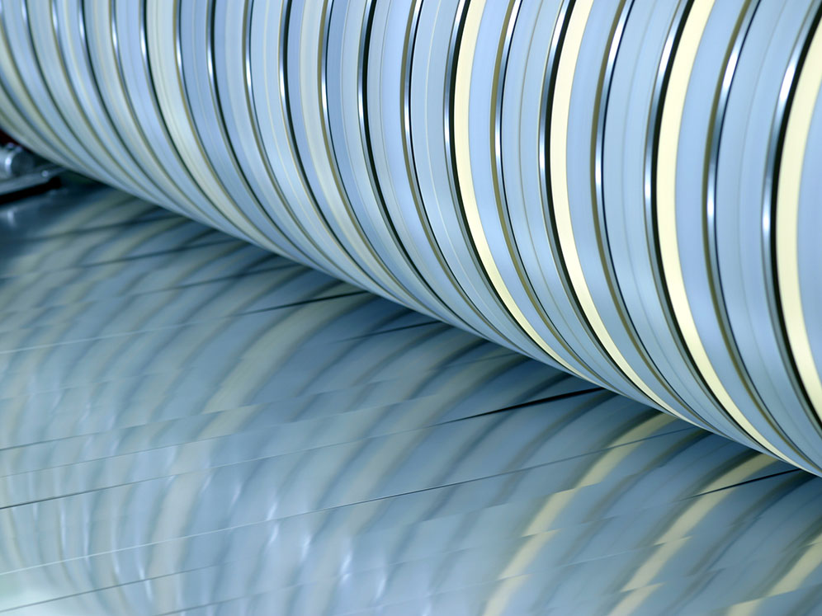

Cutter assembly with spacers and cutters

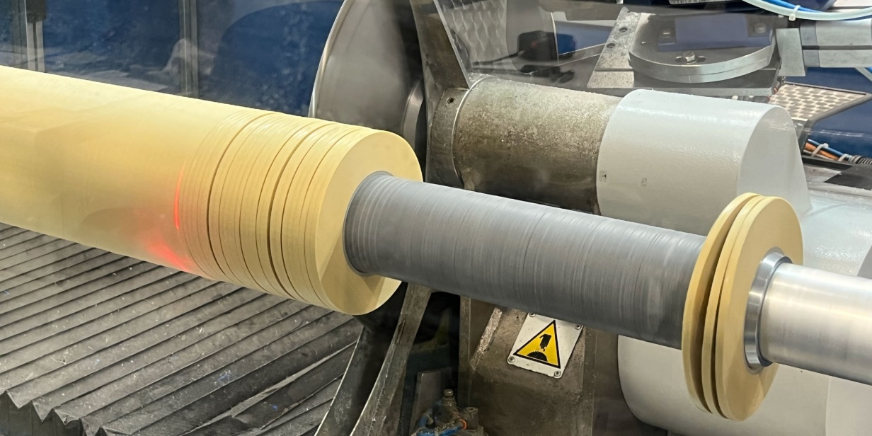

Cutter head with spacers

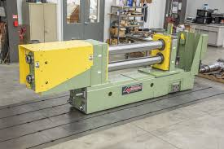
Cutter head assembly

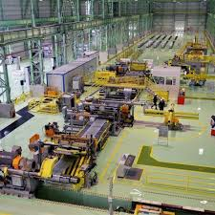

Plant complete view

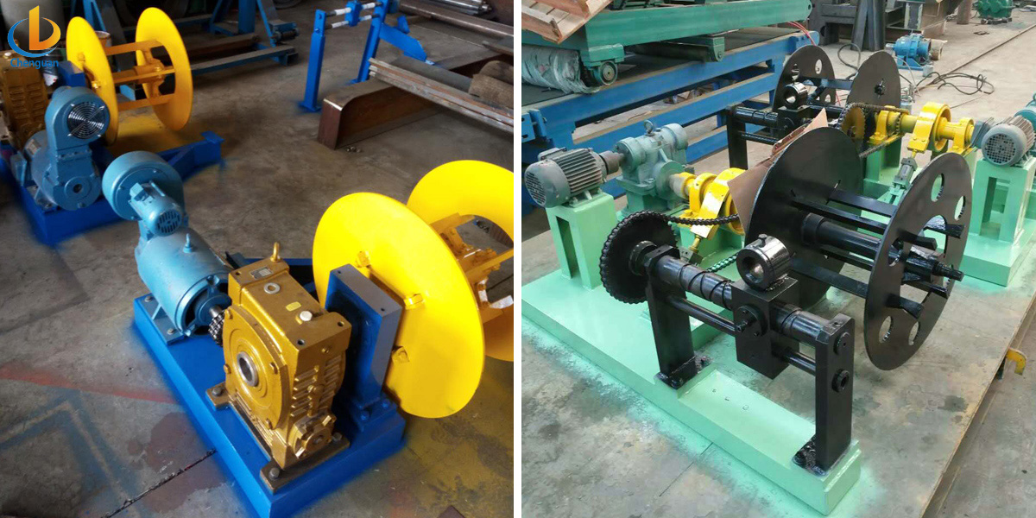

Scrap winders

GENERAL TERMS & CONDITIONS:
- Price quoted per unit : ex-works. Hyderabad.
- Following charges are additional to your account.
- Freight Charge : As actual to be borne by you.
- Packing charge : As actual to be borne by you.
- Excise Duty : Extra @ 12.36%
- Sales Tax : Extra @ 2% against ‘C’ Form
- Insurance : As actual to be borne by you.
- Payment : 50% advance along with order balance before delivery but after inspection at our works.
- Delivery With in 7 months from date of advance received
- Validity : One month from the date of submission.
- Inspection : Inspection at our works prior to dispatch.
- Warranty : 12 months from the date of dispatch against any manufacturing defects/ faulty material or bad workmanship of any part or component but not against any kind of abnormal or improper use of machine. Defective part or component will be replaced or repaired free of cost. Electrical components are outside the scope of this warranty.
- Commissioning : Erection & commissioning done by you, but required technical support & guidance provide by us at additional cost.

NOTE:
- Oil is not in scope of our supply.
- Raw material for trial is to be arranged by you at your cost.

We hope our offer is to your expectation and meet your requirement. Please contact Sivaramakrishnan, (Mob: 9246221106/9849207176) EMail: srktalam@gmail.com further information / clarifications required if any.

Thanking you and assuring you of our best services always.

For TECHNO MACHINE TOOLS

( T. SIVARAMAKRISHNA)

